CD Cover 2003-11-07

- Here be dragons...
CD Cover 2003-11-07

H
H
H
H
F
F
E
d
A
b
c
E
G
H
I
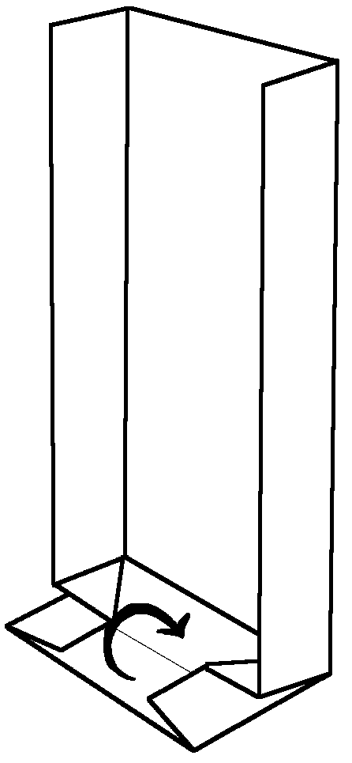
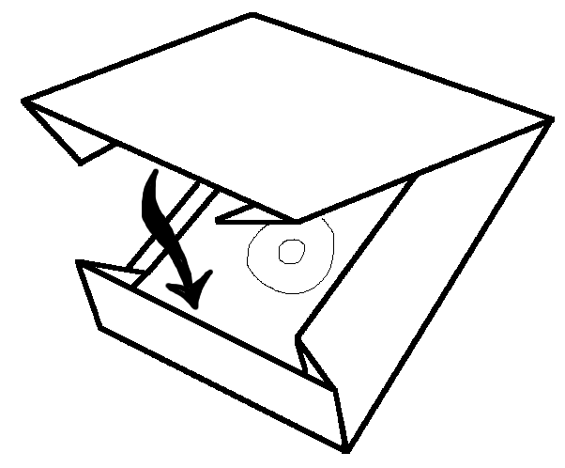
Fold: I
Fold: G
- You may choose to cut off the area separated by line A, especially if you use thick paper
- Fold paper along the straight lines
- Dashed lines are folded invards, solid lines outwards
- Make folding in alphapetical order (A-I)
- Capital letter folds remain tightly folded to the end. Lower letter folds may be opened immediately.
- The illustrations below should help in the tricky parts
A4 Origami CD Cover
(c) Petri Honkamaa, 2003
You may use this design freely, but please don't remove the copyright notice

